UNIVERSITY OF MANAGEMENT AND TECHNOLOGY



Submitted by:

ABYAN KHAN

ID: F2024332003

Subject:

Introduction to Data Science

Resource Person:
Arsalan Ahmed

Date of Submission:

17/05/2026

Assignment 1
Part A: Python Programming (Jupyter Notebook)
This section contains the comprehensive source code implementations, structural breakdowns, and mathematical operations executed within the Jupyter Notebook environment.
Q1. Arithmetic and Assignment Operators
Demonstrates initialization of numeric types, core arithmetic operations, and sequential variable modification using shorthand assignment operators.
# Variable Initialization
a = 15
b = 4
# Arithmetic Operations
print(f"Addition (a + b): {a + b}") # Output: 19
print(f"Subtraction (a - b): {a - b}") # Output: 11
print(f"Multiplication (a * b): {a * b}") # Output: 60
print(f"Division (a / b): {a / b}") # Output: 3.75
print(f"Floor Division (a // b): {a // b}") # Output: 3
print(f"Modulus (a % b): {a % b}") # Output: 3
print(f"Exponentiation (a ** b): {a ** b}") # Output: 50625
# Assignment Operators Demonstration
a += 5 # Equivalent to a = a + 5 -> 20
print(f"After a += 5: {a}")
a -= 3 # Equivalent to a = a - 3 -> 17
print(f"After a -= 3: {a}")
a *= 2 # Equivalent to a = a * 2 -> 34
print(f"After a *= 2: {a}")
a /= 4 # Equivalent to a = a / 4 -> 8.5
print(f"After a /= 4: {a}")
Q2. Comparison and Logical Operators
Evaluates relational boundaries between interactive user inputs and demonstrates truth-value matrices using logical gates (and, or, not).
# User input sequence
num1 = int(input("Enter first integer: ")) # Assume 10
num2 = int(input("Enter second integer: ")) # Assume 20
# Comparison Expressions
print(f"{num1} == {num2}: {num1 == num2}") # Equal to: False
print(f"{num1} != {num2}: {num1 != num2}") # Not equal to: True
print(f"{num1} > {num2}: {num1 > num2}") # Greater than: False
print(f"{num1} < {num2}: {num1 < num2}") # Less than: True
print(f"{num1} >= {num2}: {num1 >= num2}") # Greater than or equal: False
print(f"{num1} <= {num2}: {num1 <= num2}") # Less than or equal: True
# Logical Gate Testing
cond1 = (num1 < num2) # True
cond2 = (num1 > 5) # True
print(f"cond1 and cond2: {cond1 and cond2}") # True if both are true: True
print(f"cond1 or cond2: {cond1 or cond2}") # True if at least one is true: True
print(f"not cond1: {not cond1}") # Reverses current state: False
Q3. Bitwise Operators
Performs element-level operations on the binary representations of integers.
x = 6 # Binary: 0110
y = 3 # Binary: 0011
print(f"Bitwise AND (x & y): {x & y}") # 0010 -> 2
print(f"Bitwise OR (x | y): {x | y}") # 0111 -> 7
print(f"Bitwise XOR (x ^ y): {x ^ y}") # 0101 -> 5
print(f"Bitwise NOT (~x): {~x}") # -(x+1) -> -7
print(f"Left Shift (x << 2): {x << 2}") # 011000 -> 24
print(f"Right Shift (x >> 1): {x >> 1}") # 0011 -> 3
Q4. Identity and Membership Operators
Differentiates memory addresses references (identity) and scans sequence blocks for membership containment.
# Sequence Initialization
numbers_list = [10, 22, 35, 47, 50]
list_copy = numbers_list
duplicate_list = [10, 22, 35, 47, 50]
# Identity Verification (Memory reference matching)
print(f"list_copy is numbers_list: {list_copy is numbers_list}") # True (Same reference)
print(f"duplicate_list is numbers_list: {duplicate_list is numbers_list}") # False (Different reference)
print(f"duplicate_list == numbers_list: {duplicate_list == numbers_list}") # True (Values match)
# Membership Validation
search_val = 35
print(f"{search_val} in numbers_list: {search_val in numbers_list}") # True
print(f"100 not in numbers_list: {100 not in numbers_list}") # True
Q5. String Operations
Manipulates alpha-numeric string sequences using internal methods, containment operations, and substring slicing arrays.
sentence = "Data Science with Python is highly efficient and foundational."
print(f"1. String Length: {len(sentence)}")
print(f"2. Uppercase conversion: '{sentence.upper()}'")
print(f"3. Lowercase conversion: '{sentence.lower()}'")
print(f"4. Is 'Python' present?: {'Python' in sentence}")
print(f"5. Replacing word: '{sentence.replace('foundational', 'essential')}'")
print(f"6. Slicing portion (indices 0-12): '{sentence[0:12]}'")
print(f"7. Reversed structural view: '{sentence[::-1]}'")
Part B: Git & GitHub Submission Summary
This section outlines the workflow tracking log used to initialize, save, and export the assignment to the cloud repository via Git version control engine terminal interface.
Step 1: Initialize the Local Repository
Command Used: git init
Explanation: This command initializes a brand-new, empty local Git repository inside the designated project directory. It establishes a hidden tracking directory (.git) that enables version control and state snapshot tracking within the directory structure.
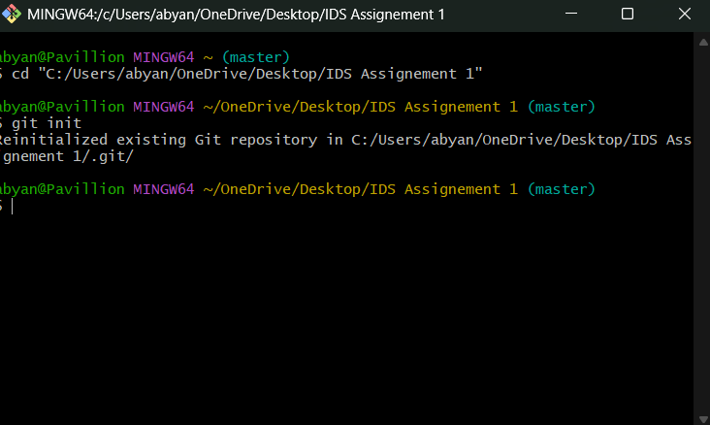
Step 2: Stage and Commit the Project Files
Commands Used: git add . && git commit -m "Initial commit with Jupyter Notebook"
Explanation: The command 'git add .' groups all newly modified or untracked files in the directory tree and places them in the Staging Index area. Running 'git commit' captures that staged metadata layer and writes it as an immutable structural block into the local history, marked by the explanatory tracking label passed via the -m flag.
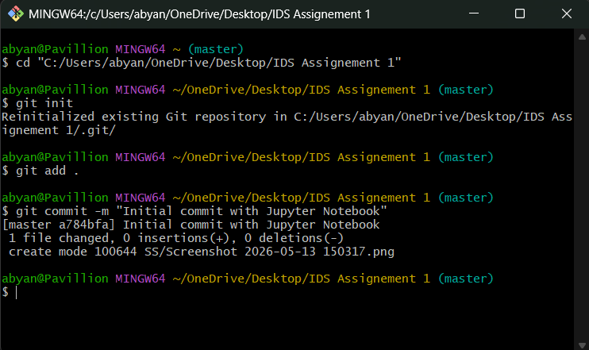
Step 3: Create a New GitHub Repository
Action: Remote Web Repository Creation via GitHub UI Dashboard
Explanation: This initializes a cloud host destination to store development logs. By creating a blank shell workspace (without adding auto-generated readmes or licenses), GitHub is prepared to bind cleanly with the existing local code architecture without mismatching branches.
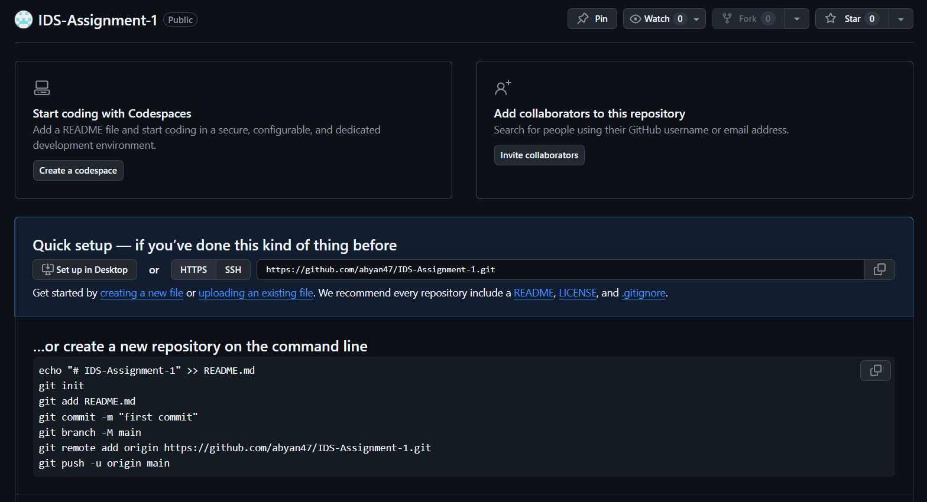
Step 4: Link Local Repository to Remote GitHub Repository
Command Used: git remote add origin https://github.com/abyan47/IDS-Assignment-1.git
Explanation: Binds the local command-line project workspace to the remote repository located on GitHub's cloud. It creates an aliased variable path labeled 'origin' that points directly to the cloud URL, routing subsequent push/pull operations.
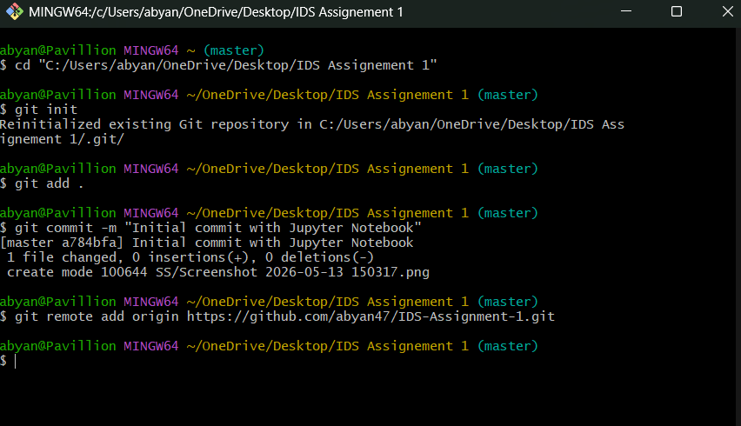
Step 5: Push Local Commits to GitHub
Command Used: git push -u origin master
Explanation: Transports local branch history up to the remote cloud hosting platform ('origin') on the designated target branch ('master'). The -u upstream flag sets a permanent tracking baseline linking the local development branch with the remote path for easier single-word commands later.
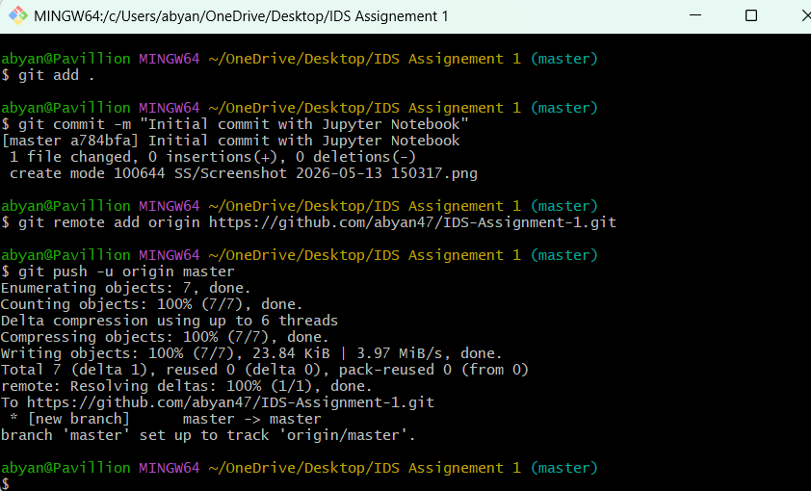

Step 6: Verify Upload on GitHub
Action: Verification Review via Web Portal UI Profile
Explanation: Provides visual validation of the cloud deployment file list tree. Looking at the public user profile profile grid tracks the contribution map update and validates that the repository language classification successfully identified the compiled Jupyter Notebook (.ipynb) source payload.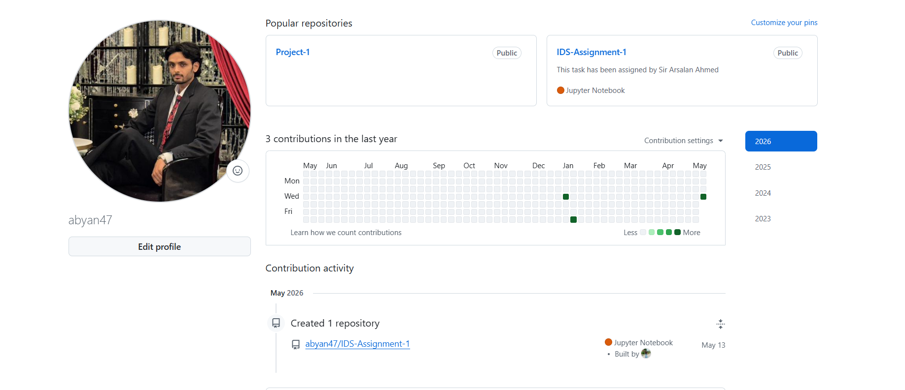
Official GitHub Repository Link
CLICK THIS TEXT TO OPEN LINK

